**Design Brief for It Movies Website**

This decorative grudge font was used exclusively for the landing text

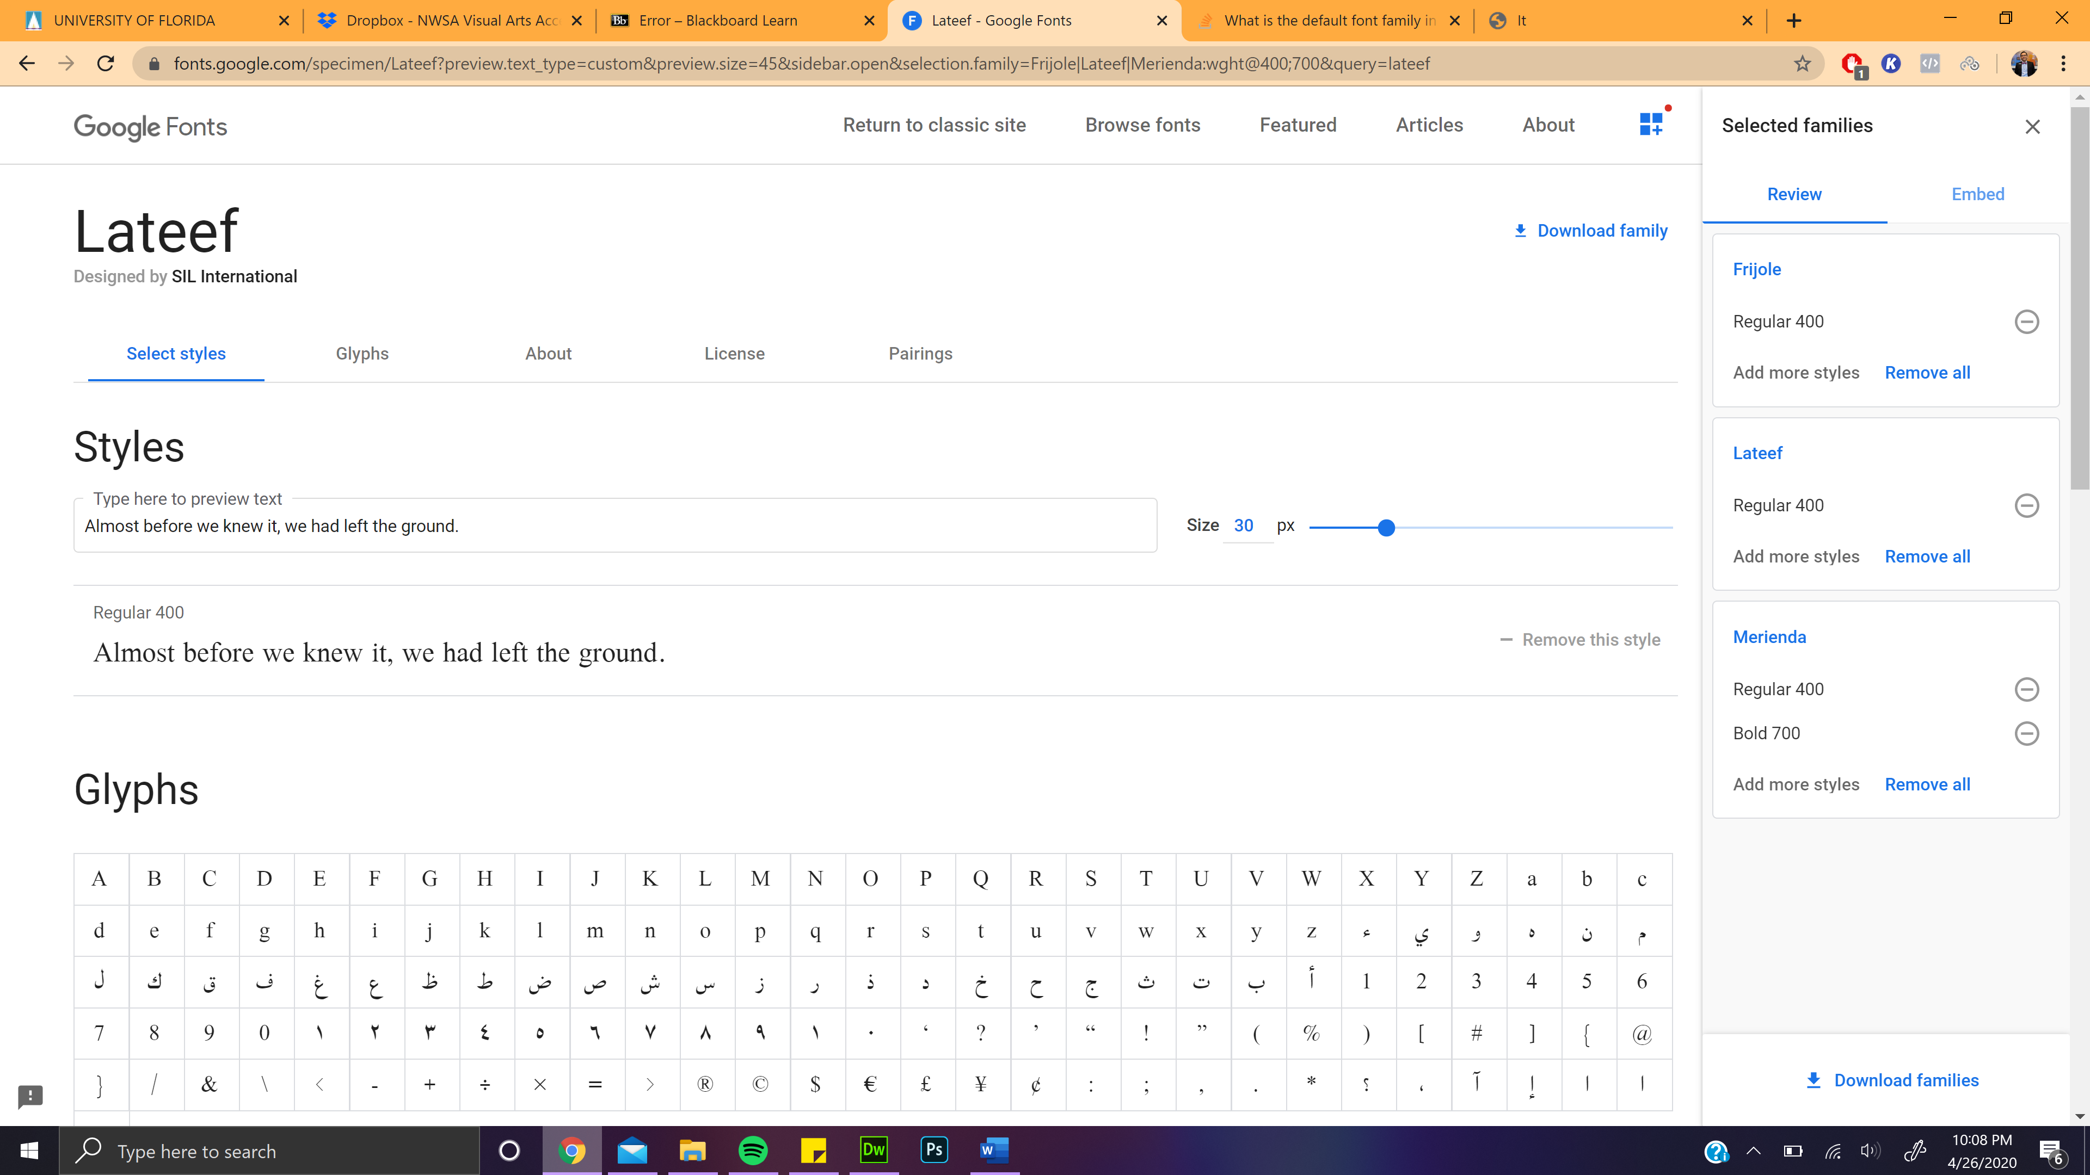

Serif font used in most body text

Decorative font used for the most dection headers; it resembles a “ghosty” feeling

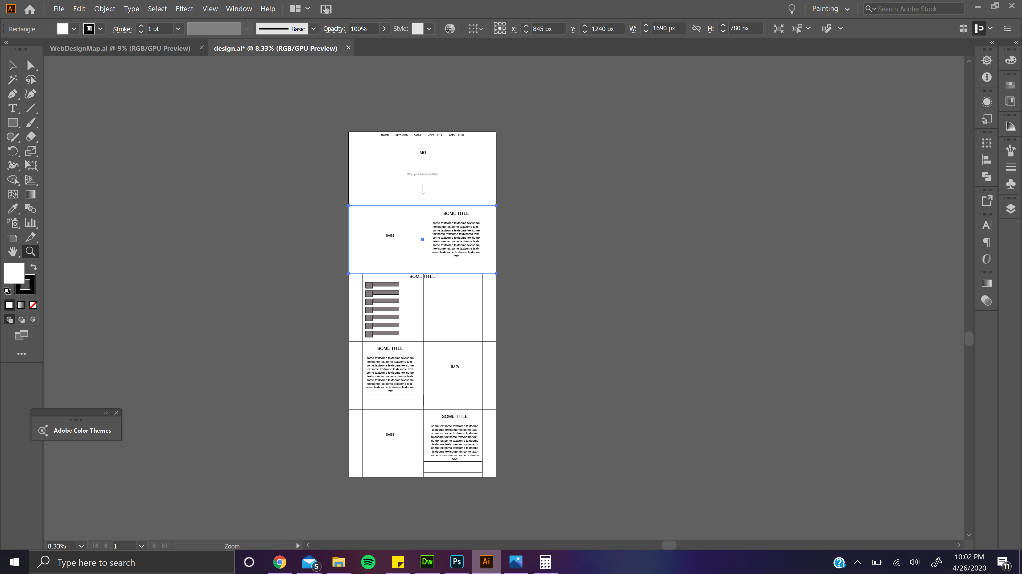

Pennywise img and reviews

IT ch. II overview and stream link

IT ch. I overview and stream link

Cast imgs and imbd link

General plot overview over a pennywise img

Landing page with pennywise img